VAHS – EAST SIDE DENTAL CLINIC
REFERRAL FORM
(We will need a copy of all the dental coverage Ids - if any)

Date: _________________________________
LAST NAME: ______________________________ FIRST NAME: _____________________________________
DOB (mm/dd/yy) ________________________ PHONE#: _________________________EMAIL _______________________
HOME ADDRESS __________________________________________________ CITY ___________ POSTAL ____________
CARE CARD # _________________________________ NATIVE STATUS CARD # ________________________________
OTHER ID# (PAROLE, REFUGEE STATUS#): ________________________________________________________________
ARE YOU UNDER: INCOME ASSISTANT / EI / DISABILITY / HEALTHY KIDS PROGRAM / WCB / ETC
INSURANCE COMPANY: ________________________________________POLICY# _______________________________
GROUP# _____________________ DIV# __________ OPTIONAL CODE _____ EMPLOYER _________________________
MEDICAL CLINIC LAST SEEN ____________________________________________________________________________
REASSON OF VISIT TO MEDICAL CLINIC _________________________________________________________________
CONTACT INFO OF YOUR MEDICAL DOCTOR _____________________________________________________________

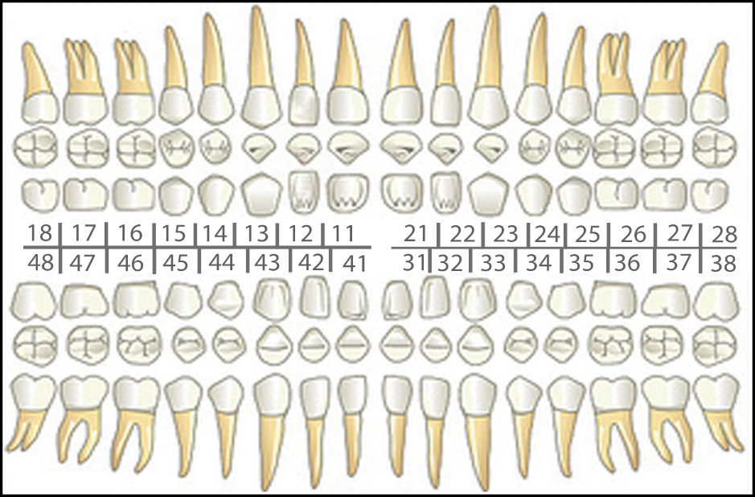

Reason for referral:

- Cancer screening
- Consultation €€
- Dental cleaning
- Dental filling
- Extraction (Simple / Surgical)
- Prosthetic treatment
- Root Canal Therapy
- X-ray (PA/CT/Panoramic)

- Others ________________________________________________________________________________________________________________________________________________________________________________________________________________________

Clinical Remarks:
______________________________________________________________________________
______________________________________________________________________________
______________________________________________________________________________
______________________________________________________________________________
Please include any dental record(s) if applicable by email or fax.

Referred by Dr. _______________________ Contact info: _______________________
(NAME / SIGNATURE / CDSBC#)

Rev. V.2.5 – 20190824

Thank you for the referral. “Your Patient’s care is our focus!”
We shall send you a progress letter after the initial appointment

